SOFTWARE PROCESS MODEL

1.Selection of Process Model:
For the Car Dealership Management System, the most suitable software process model is the Scrum (Agile) Model. This project includes several features such as customer interaction, car inventory management, payment processing, and administrative control. These can be developed gradually in different stages. So, Scrum process model is suitable for this project as scrum developes the system in small iterations called sprint.

Scrum Process Model:
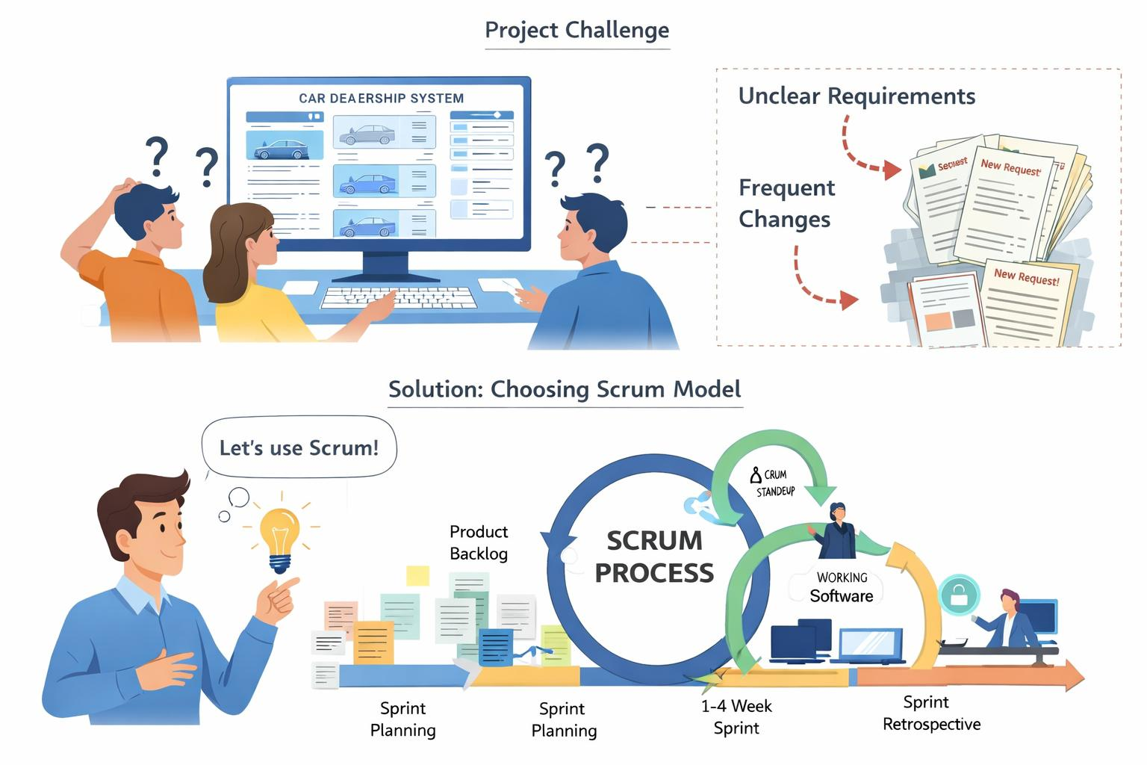

Example Sprint Breakdown:
- Sprint 1: Login, registration, car browsing
- Sprint 2: Car booking and payment
- Sprint 3: Admin panel and inventory management

Why Scrum Was Chosen for This Project
- The Car Dealership Management System may require changes in features such as car details, pricing, payment options, or admin functions. Scrum effectively handles these changes by allowing continuous updates and prioritization of the Product Backlog.
- Scrum develops the system incrementally through short development cycles called sprints, making it easier to implement complex features like customer management, booking, and inventory control in an organized manner.
- At the end of each sprint, Scrum delivers a working product increment, ensuring that usable parts of the system are available early and improved over time.
- Scrum encourages continuous feedback through Sprint Review meetings, where stakeholders can evaluate completed features and suggest improvements, leading to a more user-friendly system.
- Since testing is included in every sprint, issues are identified and fixed early, which improves the overall quality and reliability of the Car Dealership Management System.
- Scrum is highly suitable for group projects because it defines clear roles, promotes teamwork, and ensures effective communication among team members throughout the development process.

Why Scrum is Chosen
Scrum is chosen because:
- It develops the system in short sprints
- It supports changing requirements
- Daily scrum meeting
- Sprint review meeting (Last Day)
- It delivers working software incrementally
- It ensures continuous feedback and improvement

Why Other Models Were Not Selected
Model | Reason for Not Choosing
Waterfall Model | It does not support changes, backtracking once development starts, which is unsuitable for a system like a Car Dealership Management System where requirements may change.
V-Model | Although it emphasizes testing, it is still like the Waterfall model and does not handle frequent requirement changes and backtracking well.
XP (Extreme Programming) | It requires highly experienced developers and continuous customer involvement, which is difficult to maintain in a student group project.
Prototyping Model | It mainly focuses on quick user interface development and may lead to incomplete system design if used alone. It is not ideal for managing a full system with many modules.
Iterative Model | Although it supports iteration, it lacks clearly defined roles, sprint planning, and structured feedback mechanisms compared to Scrum.
DSDM | It involves heavy documentation and strict control mechanisms, which can be difficult and time-consuming for students to manage.

